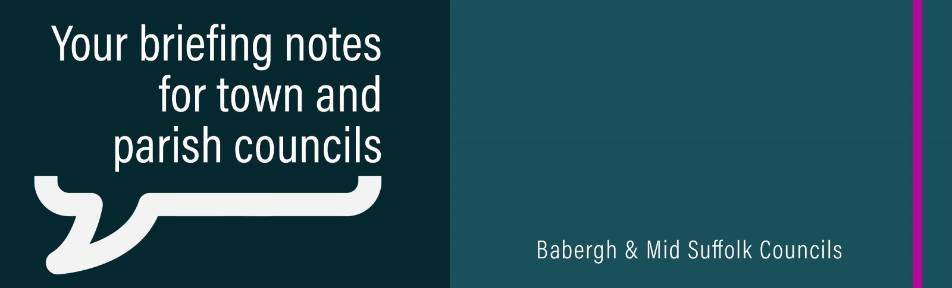

Have your say: Residents invited to help shape future of Babergh and Mid Suffolk
Residents, businesses, community groups and stakeholders are being invited to help shape the future of Babergh and Mid Suffolk as the councils launch the first stage of consultation on their new Joint Local Plan. If you have a place to display any promotional material about the consultation, a poster is attached to this email.
Service personnel championed during Suffolk’s Armed Forces Day celebrations
Hundreds of people gathered in Stowmarket to join in with Suffolk’s Armed Forces Day celebrations, coming together for a day of both family fun and reflection.
Green light for nature reserve after £50k funding
A new nature reserve protecting a rare and threatened habitat in Mid Suffolk is a step closer to being created after receiving a funding boost in the first round of Community Nature Recovery Grants.
Scheduled work at leisure centre will mean temporary pool closure
Scheduled maintenance work will take place at Stradbroke Leisure Centre this summer, resulting in a temporary three-week pool closure.
£45 million manufacturing facility opens at Gateway 14
More than 250 local businesses, government officials, suppliers, partners and community representatives gathered today to celebrate the official opening of Assan Panel UK's new £45 million manufacturing facility at Gateway 14 in Suffolk.
New Stowmarket High School Expansion Teaching Block Takes Shape
Stowmarket High School has reached a major construction milestone, with a ‘Steel Signing’ event taking place at its new expansion building.
Mid Suffolk Disability Forum meeting: Wednesday 29 July, 10:30am via Zoom
The Mid Suffolk Disability Forum is a network of disabled people, families and organisations which works to improve the lives of disabled people living in the area. Supported by Mid Suffolk District Council, it creates a stronger, collective voice for positive change. Membership is free and meetings are open to all Mid Suffolk residents with any disability, as well as carers, local disability organisations, council and town/parish council representatives. To join, email midsuffolkdisforum@btinternet.com and they will be pleased to welcome you.
Families in Mid Suffolk urged to claim Healthy Start support
Families across Mid Suffolk are being encouraged to check if they are eligible for the Healthy Start Scheme – with a recent increase in payment levels putting even more money into the hands of those who need it most.
New campaign launched to showcase Suffolk vineyards
A new Suffolk Wine Trail has been launched to help showcase Suffolk’s growing collection of local vineyards.
Residents urged not to miss out on heating oil help
Babergh and Mid Suffolk District Councils have joined forces with local Citizens Advice services to reach residents who may be missing out on financial help with heating oil – having already helped households unlock £100k in unclaimed benefits over the last year.
Pride in Your Place
Applications for Mid Suffolk District Council’s Pride in Your Place grant have reopened, offering funding to projects that bolster community pride and celebrate the heritage of towns and villages across the district.
New Mid Suffolk Chair selects Suffolk Lowland Search and Rescue as charity
Suffolk Lowland Search and Rescue has been named as charity of the year for Mid Suffolk District Council.

